Directions: Calculate the side lengths. Solutions should be in fully simplified radical form – no decimal answers!
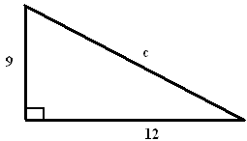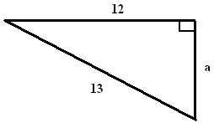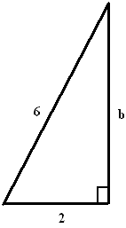

c = ___________ a = ___________ b = ___________

Directions: Calculate the distance between the following points.

(9, 4) and (6, -2) (2, -10) and (-2, -6)

d = ________ d = ________

Find y if the distance between the points (-2, 5) and (6, y) is 10. y = ________

